Experiment No: 8

Title: Simulation of Healthcare Monitoring System Using Python (Google Colab)

Aim
To develop and simulate a Healthcare Monitoring System using Python in Google Colab that generates patient vital signs, monitors for abnormalities, classifies patient status as normal or emergency , and visualizes health parameters through real-time graphs and a final report.

Objective
The objective of this experiment is to simulate a healthcare environment where multiple patients’ vitals (temperature, heart rate, SpO₂) are continuously monitored. The system generates random patient data, evaluates health status against medical thresholds, and classifies patients as either NORMAL or EMERGENCY. Results are displayed in real-time graphs and stored in a CSV report. This experiment demonstrates how healthcare monitoring can be implemented through simulation using Python in Google Colab.

Software Requirements
- Google Colab
- Python 3.x
- Libraries:
  - random → generate patient vitals
  - time → simulate delays
  - pandas → tabular report generation
  - matplotlib → graphical visualization
  - IPython.display → clear and update live output

Theory
A Healthcare Monitoring System ensures patient safety by continuously tracking vital signs. In real-world hospitals, IoT devices and sensors are used to detect abnormalities and alert medical staff. Since physical devices are not used in this experiment, patient data is simulated using random values. The system evaluates each patient’s vitals against medical thresholds, classifies them as NORMAL or EMERGENCY, and visualizes the results through graphs. This simulation demonstrates the working principle of a real-time healthcare monitoring system without requiring physical sensors or hospital infrastructure.

Algorithm
- Start the program.
- Import required Python libraries.
- Create a list of patient names.
- For each patient:
  - Generate random values for temperature, heart rate, and SpO₂.
  - Compare values with medical thresholds.
  - Classify patient as NORMAL or EMERGENCY.
  - Display patient details and plot graphs.
- Pause simulation for 2 seconds.
- Store patient data in a DataFrame.
- Display final report table.
- Save report as CSV file.
- Stop the program.

Flowchart
Code
START
|
Import Libraries
|
Generate Patient Data
|
Check Thresholds
|
┌─────────────┴─────────────┐
| |
NORMAL EMERGENCY
| |
└─────────────┬─────────────┘
|
Display Graphs & Status
|
Store Patient Data
|
Generate Final Report
|
END

Program Description
The Python program simulates patient monitoring across multiple patients. Each patient’s vitals (temperature, heart rate, SpO₂) are randomly generated and evaluated against thresholds. Patients are classified as NORMAL or EMERGENCY. Results are displayed in real-time graphs and stored in a CSV file. The system provides a clear summary of patient health status, demonstrating how healthcare monitoring can be applied in a simulated environment.

Input
- Patient Names
- Temperature Values
- Heart Rate Values
- SpO₂ Values

Output
- Patient Health Report Table
- Real-time Graphs:
  - Temperature
  - Heart Rate
  - SpO₂
- Final CSV Report

Observations
- Patients with abnormal vitals are classified as EMERGENCY.
- Normal patients are classified as SAFE.
- Graphs clearly visualize patient health status.
- Final report provides a summary of all patients.

Applications
- Hospital Monitoring Systems
- IoT-based Healthcare Devices
- Remote Patient Monitoring
- Medical Training Simulations

Advantages
- Real-time patient monitoring
- Automatic abnormality detection
- Graphical visualization of health status
- Easy to understand and implement
- Cost-effective simulation without real sensors

Limitations
- Uses simulated patient data
- No real medical devices involved
- Does not notify doctors in real time
- Suitable only for academic demonstration

PROGRAM
# ===========================================
# Case Study : Healthcare Monitoring System
# Google Colab Simulation
# ===========================================

import random
import time
import pandas as pd
import matplotlib.pyplot as plt
from IPython.display import clear_output

# -------------------------
# Patient Names
# -------------------------

patients = [
"Patient 1","Patient 2","Patient 3","Patient 4","Patient 5",
"Patient 6","Patient 7","Patient 8","Patient 9","Patient 10"
]

temperature_data=[]
heart_data=[]
spo2_data=[]

# -------------------------
# Simulation
# -------------------------

for patient in patients:

temp=round(random.uniform(35.5,40.5),1)
heart=random.randint(55,130)
spo2=random.randint(88,100)

temperature_data.append(temp)
heart_data.append(heart)
spo2_data.append(spo2)

if temp>38 or heart>110 or spo2<92:
status="EMERGENCY"
color="red"
else:
status="NORMAL"
color="green"

clear_output(wait=True)

print("="*60)
print("HEALTHCARE MONITORING SYSTEM")
print("="*60)
print("Patient :",patient)
print("Temperature :",temp,"°C")
print("Heart Rate :",heart,"BPM")
print("SpO2 :",spo2,"%")
print("Status :",status)

plt.figure(figsize=(12,4))

# Temperature
plt.subplot(1,3,1)
plt.bar(["Temp"],[temp],color="orange")
plt.ylim(30,45)
plt.title("Temperature")

# Heart Rate
plt.subplot(1,3,2)
plt.bar(["Heart"],[heart],color="blue")
plt.ylim(40,150)
plt.title("Heart Rate")

# SpO2
plt.subplot(1,3,3)
plt.bar(["SpO2"],[spo2],color=color)
plt.ylim(80,100)
plt.title("SpO2")

plt.tight_layout()
plt.show()

time.sleep(2)

# -------------------------
# Final Report
# -------------------------

report=pd.DataFrame({

"Patient":patients,
"Temperature":temperature_data,
"Heart Rate":heart_data,
"SpO2":spo2_data

})

print("\nFINAL REPORT\n")
print(report)

report.to_csv("Healthcare_Report.csv",index=False)

print("\nCSV File Saved Successfully")

Result
The Healthcare Monitoring System was successfully simulated using Python in Google Colab. The system generated patient vitals, detected abnormalities, classified patients as NORMAL or EMERGENCY, and displayed results through graphs and a final CSV report. Thus, the experiment demonstrated effective healthcare monitoring and visualization in a simulated environment.

OUTPUT
============================================================
HEALTHCARE MONITORING SYSTEM
============================================================
Patient : Patient 10
Temperature : 36.7 °C
Heart Rate : 69 BPM
SpO2 : 99 %
Status : NORMAL
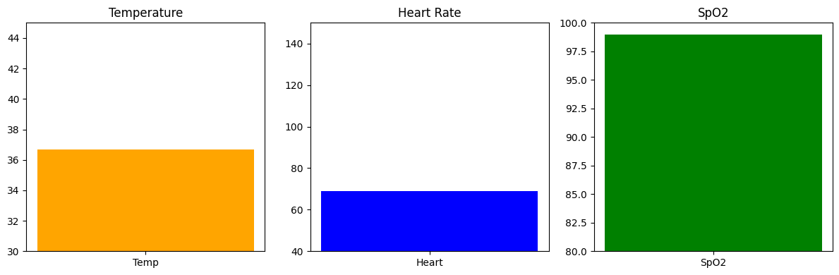
FINAL REPORT

Patient Temperature Heart Rate SpO2
0 Patient 1 37.7 93 88
1 Patient 2 38.0 104 95
2 Patient 3 40.5 67 100
3 Patient 4 35.8 102 99
4 Patient 5 36.5 79 89
5 Patient 6 38.6 93 89
6 Patient 7 37.4 67 91
7 Patient 8 37.2 121 90
8 Patient 9 38.4 66 91
9 Patient 10 36.7 69 99

CSV File Saved Successfully

